Document name | FET Mini Project
Version no. | 1.0
Release date | Jan- 2023
Classification | Departmental



This document of Cybage Software Pvt. Ltd. is for restricted circulation. No part of this publication may be reproduced, stored in a retrieval system or transmitted in any form or by any means – recording, photocopying, electronic and mechanical, without prior written permission of Cybage Software Pvt. Ltd.
FET Mini Project

Document History

Ver. No | Release Date | Created By / Modified By and Date | Reviewed By and Date | Approved By and Date | Remarks and Changes Made
0.1 | Jan 2023 | Sonali Mindhe | Shreyas Gune <shreyasg@cybage.com> | Shreyas Gune <shreyasg@cybage.com> | Initial draft.

BookMe.com
This platform will serve needs of audience who wish to attend live performances. From fetching events based on user’s interest to catching up with like-minded folks this platform makes an experience more enriching for you. Get to know your favourite artist, track their events. No worry about food, get early bird discount on food, loyalty benefit on event ticket and much more. Leave and see feedbacks.

Choose City
User will be required to select city/particular location to fetch all events in that area.

- Search
A. Filter for Movies, Dramas, Sports, Music Show categories
B. Search by particular artist
C. Search by Date
D. Search by Price

- Login functionality
Login Types:-
A. Audience
Ask details if new user to register.
or login credentials if already registered.

- Highlights
Highlight events based on interest tags on home page.
Interest tags will be defined by user on their profile.
Show suggestions based on tags.

- Bio Page
Information regarding artist with picture.
- Event Details
After the event page opens, show details like map location, seats remaining, event description, date time etc.
Show seats layout and price categories, show booked seats.
Add on meal with options and prices available. Or advance meal coupon can be purchased with 20% discount on actual rates at venue.

- Booking process
  - Select seat.
  - Select Meal Coupon/Item.
  - Add loyalty points - People who have attended event in past can avail benefit of reduced price.
  - Payment (dummy payment gateway page as “Pay On Venue” feature)

- Feedback
Feedback section after the user attends the event on event page to so users can see genuine feedback.

Popcorn Box App Sample screen-

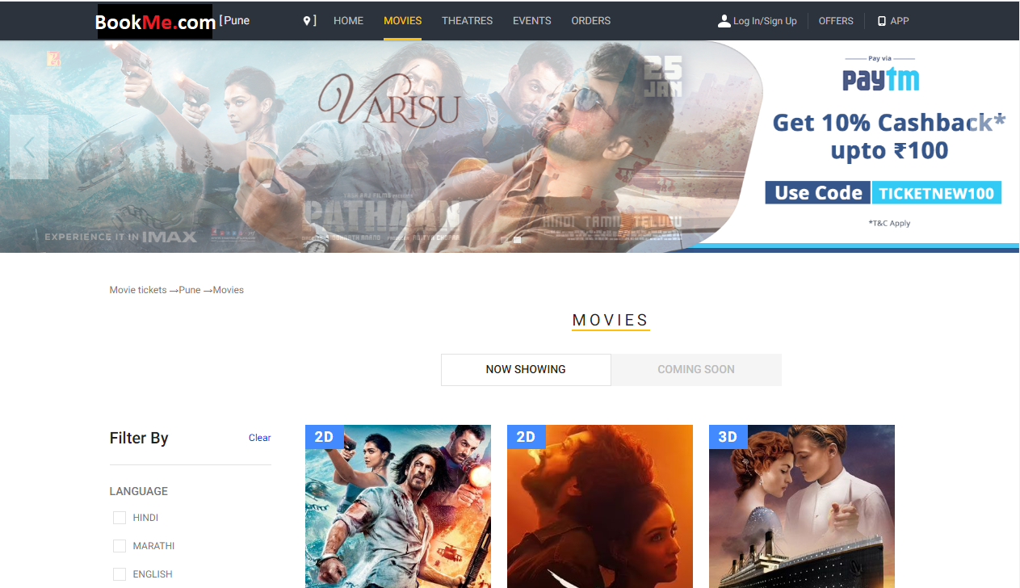

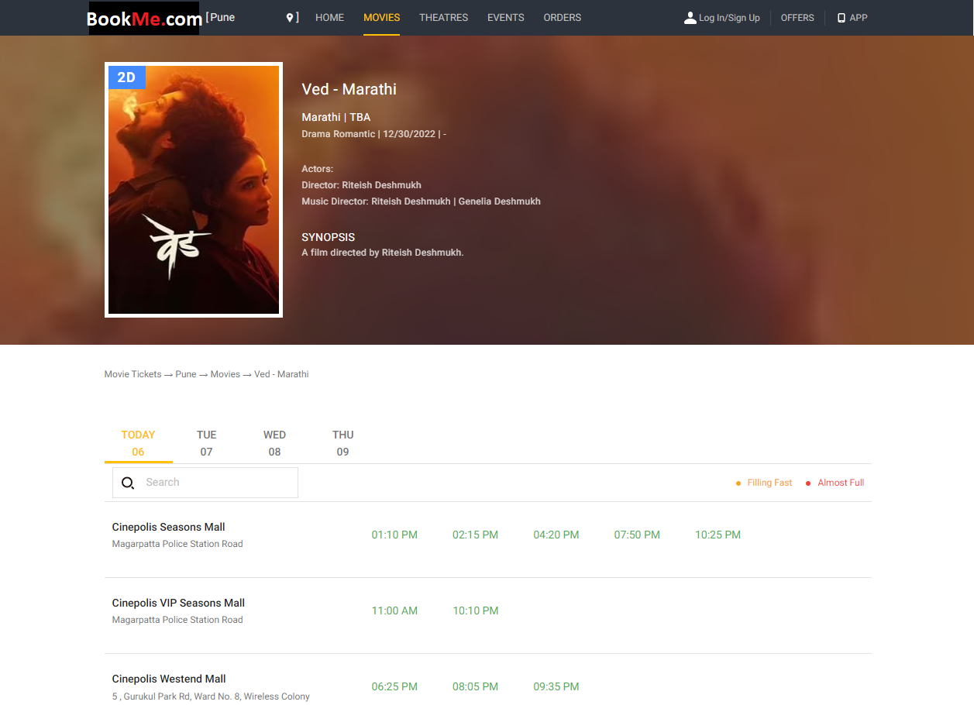

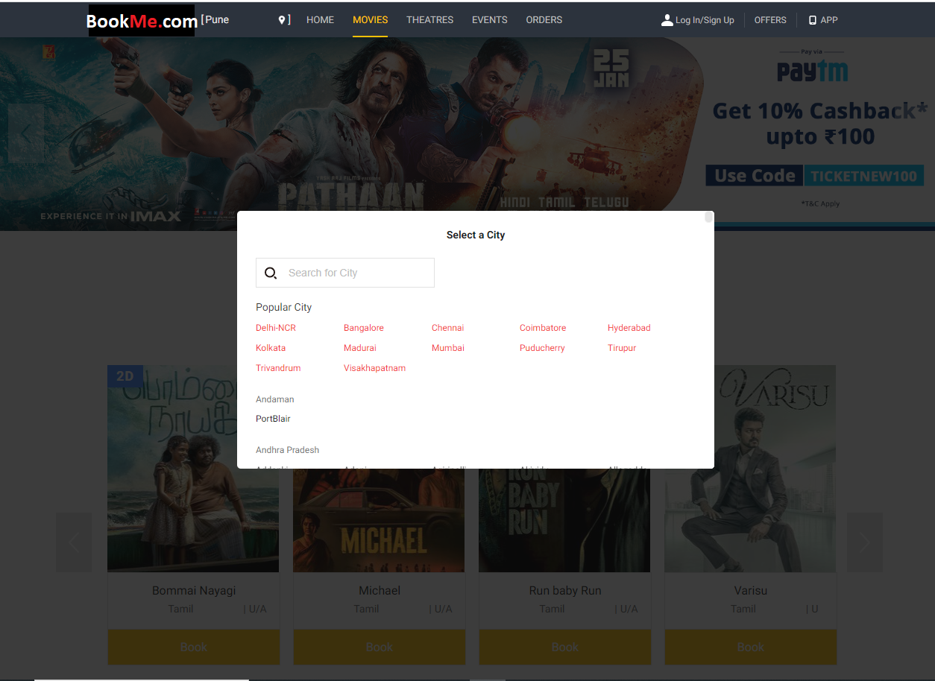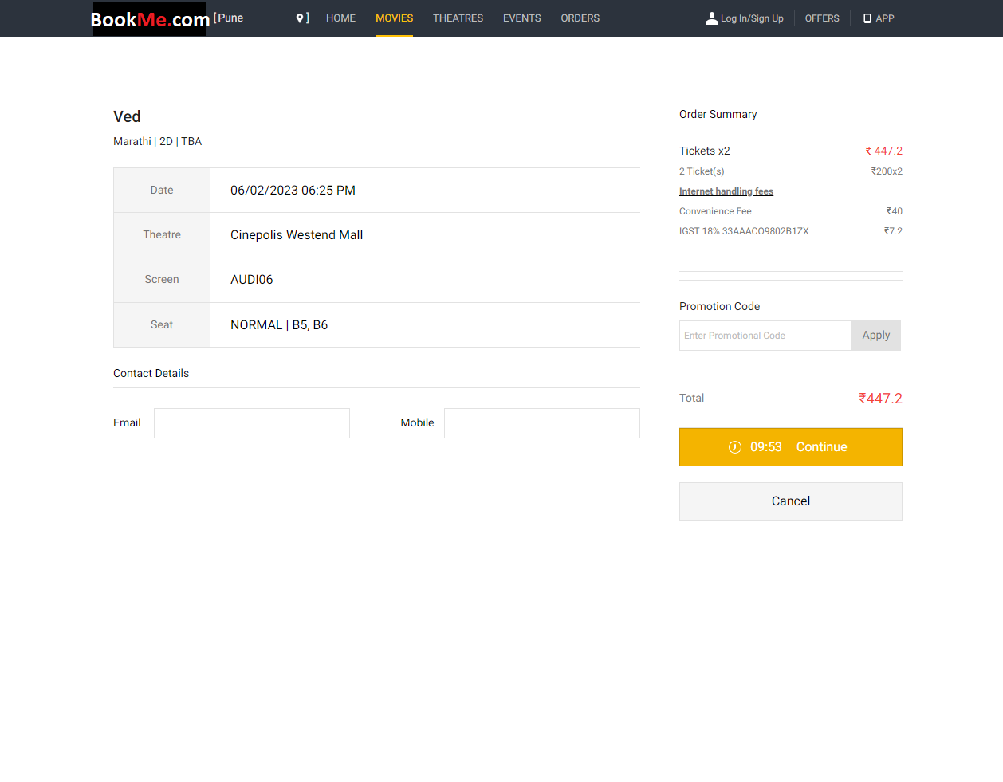
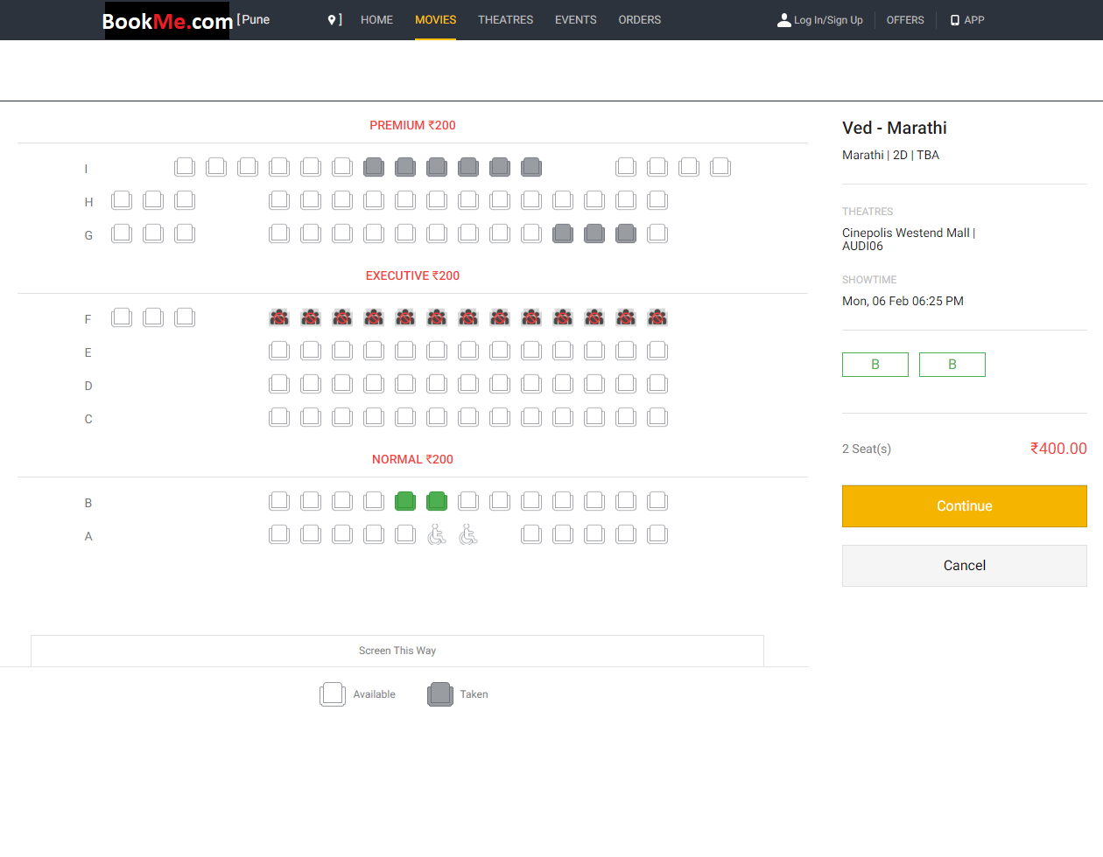

Note: You are expected to create mock API’s and perform all crud operations on them using (JSON Server)

Technologies to be used-

- HTML5
- CSS3
- JavaScript
- jQuery
- SCSS
- Bootstrap
- RWD

Tools-
- Static code validator – Linter/Hinter
- Code coverage reports – SonarQube
- Push your task daily on repository (GitHub/TFS).

Software Required -
- Editors – VS Code, Eclipse, etc.
- Chrome / Mozilla browser.

Note-
Make assumptions whenever required in the project.

Reference Link-
https://in.bookmyshow.com/explore/home/pune

